

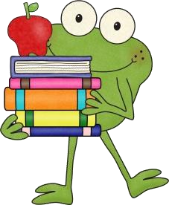
A Reading Log for Writing too!

Send this reading log home weekly or once a month.

- Monday: Students read for 15-20 minutes and then write a summary of their reading using the words first, next, then, finally.

- Tuesday: Students read for 15-20 minutes and then write an opinion about their reading. It can be what they thought of the book or something about the
character or setting.

- Wednesday: Students read for 15-20 minutes from any non-fiction resource. The students write 3 facts from their reading.

- Thursday: Students monitor their reading with fluency. They practice reading the same paragraph several times. Then the student finds someone at home to time them for 1 minute and record their words per minute. Students can use their own chapter books or the teacher can provide a passage on the back of the reading log to practice fluency.

Reading Log for : _________________________
Monday minutes read: _____________ Parent initials: _______________
Write a summary of your reading. Use the words first, next, then, finally.
_________________________________________________________________________________ __________________________________________________________________________________ _________________________________________________________________________________

__________________ ________________________________________________________________ __________________________________________________________________________________

___________________
Tuesday minutes read: _________________ Parent initials: _______________

Write an Opinion and some Reasons for your opinion.

Title: ______________________________________________________________________________________

Write an Opinion: ____________________________________________________________________

Write 2 reasons why you think this.



- _____________________________________________________________________________________________

- ____________________________________________________________________________________________

Wednesday Non-Fiction Reading minutes read: _______________ Parent initials: _______
Title of Non-Fiction Book: _________________________________________________________________________

Write three facts from your non-fiction reading (book, newspaper, on-line website, encyclopedia, etc.)

  - _______________________________________________________________________________________________
  - _______________________________________________________________________________________________
  - _______________________________________________________________________________________________

Thursday

15
-
20
minute reading

Check your fluency
!

Pick a page in your chapter book you are reading. Practice reading the same page 3 times.
Find someone to time you for 1 minute on your reading.
How was your reading? Record it here:
Title of book: ____________________________________________________ Page #: ___________

Mistakes: _____________ WPM: _______________ Parent initials: _______
©Teacher’s Take-Out

Thank you for downloading this Freebie!

Visit my blog for more ideas and activities to use in the classroom.

Visit my Facebook Page too!
Sometime I have flash freebies on FB.
To receive notification on my new products, freebies, sales, and giveaways, you can follow me here.

Thank
Y
ou

Credits/Graphics:  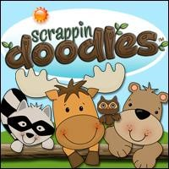   | Need More?    

